Tutorial 9: Introduction to REST
- Model code
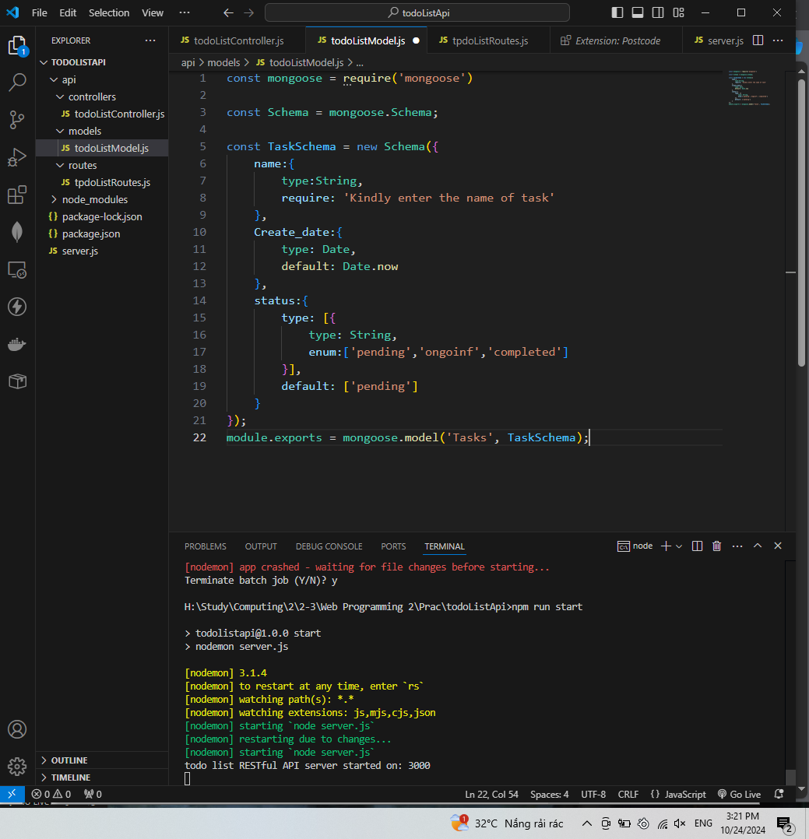
This is the place to define the requirements of the data model. The Mongoose library is employed to serve as the intermediary between the application and the database. The Schema class is provided by the Mongoose library.
The format for model ‘TaskSchema’ is created as a new intance of the Schema class. The model has 3 attributes: name, Create_data and status. Each distribute is defined using key:value pair. The key is the name of the attribute, and the value is type.
Finally, TaskSchema is solidified as a data model and export to ‘Tasks’ file which is use in other areas of the project.
- Server running on with Nodemon on Port 3000
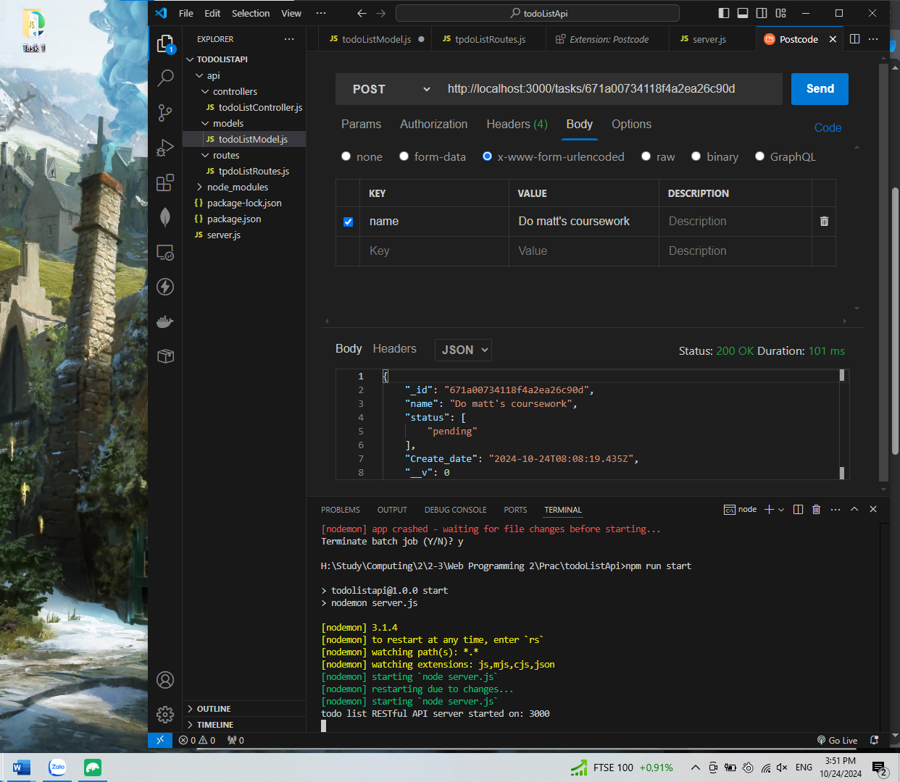
Using command ‘npm run start’ to run the config "start": "nodemon server.js" in the package.json and run the server,js
- API connected in Postcode showing some data from your database
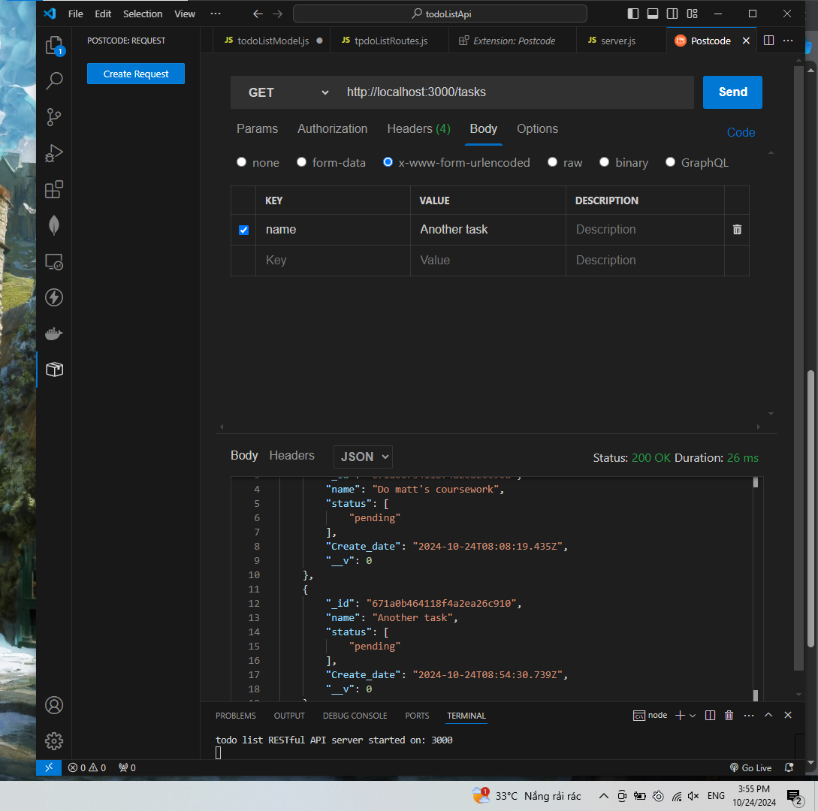
Using Postcode to test the task. Test Get to retrieve all the list of tasks. The output is JSON concluding all the task.
- Data in mongoDB
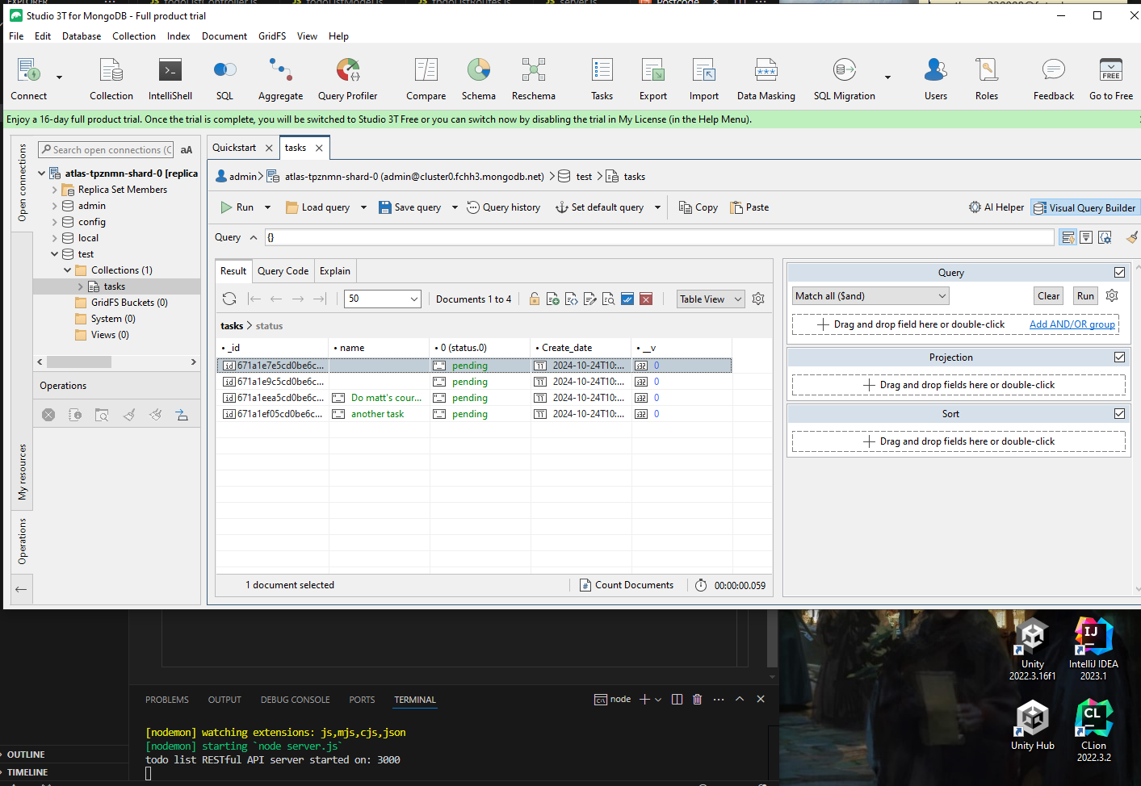
The database connected to the app so POST, GET request and the server response to the database.
A basic RESTful API (Representational State Transfer) is a web service that facilitates client-server communication using HTTP methods like POST, GET, PUT, and DELETE to perform Create, Read, Update, and Delete (CRUD) operations. RESTful APIs follow principles of stateless communication and resource-based architecture, with each resource identified by a unique URL. JSON is typically used for data exchange due to its simplicity and readability. This approach enables scalable and maintainable APIs that are essential for modern web applications, making them flexible and easy to integrate.

